28/10/2026

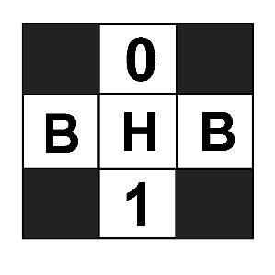

IT7510 Capstone Semester 2 Year 2026

Client Closeout Report
  - Project Title: AI-Enhanced vs Legacy Digital Forensics and Investigation Tools – A Comparative Efficacy Analysis
  - Team Name: Byte Harbor Butchers
  - Team Members: Dave Sushames, Olivia Hey, Matt Baker, Sam Davies
  - Project Client: Geoff Gordon
  - Whitireia and WelTec
  - Date of Completion: 28/10/26
Contents
The Project 2
State of the Main Deliverables 3
Deliverables Following Week 16 3
Maintenance Following Week 17 3
Key Technologies 4
Kali Linux 4
Ollama 4
Gemma4 4
GitHub 4
Forensics Tools 4
DFIR-Automation Scripts 5
DFIR LLM-Automation Script Manuals 6
Creating a Python Virtual Environment 6
Installing dependencies 7
NinemostV1 Manual 8
SilentCartographerV1 Manual 9
HammerheadV1 Manual 10
Diagnosis/Testing Support Features 11

The Project
“AI-Enhanced vs Legacy Digital Forensics and Investigation Tools – A Comparative Efficacy Analysis” investigates whether Large Language Models (LLMs) deployed locally can perform reliably in Digital Forensics and Incident Response (DFIR) contexts, especially compared to humans. The project serves to identify use cases for the application of LLM tools in DFIR, the practical limitations and challenges with such deployments, and the recommendations for parties interested in developing similar LLM-augmented solutions locally. The project primarily meets these ends by pursuing research alongside development, comparing human and LLM generated DFIR analysis reports on the same DFIR case files, and collecting and presenting qualitative and quantitative data to support the emergent findings.
To standardize and overcome specific challenges, Python scripts were necessary to take each case file, feed it appropriately to the LLM, and retrieve an output in PDF format automatically. This also avoids ad-hoc prompting and ensures repeatability. The three scripts were coded differently depending on how the subject input case file and its respective file type need to be handled. Information on how to install, use, and diagnose problems with these scripts can be found in DFIR LLM-Automation Script Manuals on page 6.
LLM models were hosted locally through Ollama on Kali Linux, ensuring that input data is not exposed to third parties. This is desirable in secure DFIR contexts and is necessary to realistically demonstrate the proof-of-concept the research presents.

State of the Main Deliverables
Table 1 - Deliverables Status
Deliverable | Status
Final project proposal | Complete
Mid-project progress presentation | Complete
Self-management review | Complete
Research Report | In progress
Client Demonstration Video | In progress
Client + Academic Closeout reports | Complete
Academic poster + One-pager | Complete
Final panel presentation | In progress

Deliverables Following Week 16
Additional research activities have been agreed to following the client concluding review. We are to test our existing data with novel frontier models such as the 125 billion parameter 256k context “Qwen3.8-flash-next” model provisioned via “Strata” instead of Ollama. The intention is to produce reports with greater theoretical truthfulness, reliability, completeness, intelligence, and speed. The team are hoping to reduce the necessity of the prompt chunking step. These new models are dependent on large quantities of non-video memory, from 35-129gbs of RAM. So, there will be some hardware acquisition and refitting required. These activities are anticipated to take 1-2 weeks.

Maintenance Following Week 17
There is no maintenance planned post week 17. The tools created during this project are purely to support research and are not expected to be published and regularly maintained. The research, supporting documents, case files, and scripts will be archived as needed and handed over to relevant parties as the project concludes.

Key Technologies
Kali Linux
An open-source Debian-based Linux distribution designed for digital forensics and penetration testing. The Kali OS natively supports the 3 traditional DFIR tools and their outputs that are the subject of this research.
Ollama
An application that hosts and serves local LLMs. It is the primary application interface that enables the configuration, execution, and monitoring of LLMs and prompts. Ollama is also the source of token-based metrics. It was chosen because it runs on a Linux command line and supports the most well regarded local LLMs.

Gemma4
A 26 billion parameter LLM that can read input data process and produce in markdown language a DFIR report that can be converted to PDF. Versions with customized parameters tuned for DFIR work have been used.
Table 2 - Gemma4 Models/Derivatives Employed During This Research
Model | Context | Temperature | Set-seed | Parameters | Appears in Data
Gemma4:26b | Default (4-64k) | 6 | No | 26 billion | No
Gemma4-df | 32k | 0 | Yes | 26 billion | Yes
Gemma4-df-64k | 64k | 0 | Yes | 26 billion | No

GitHub
A web service and application for repositories that let the team share files amongst each other for collaborative work, store all project related assets, and create audit trails for future reference.

Forensics Tools
Foremost: A digital forensics tool used to carve files from a forensic disk image. Used to recover data from hard disk storage for investigative purposes.
Nmap: A network reconnaissance tool that can be used to discover hosts, open ports, services, vulnerabilities, and other technically specific diagnostic information. Essential in mapping and assessing the security posture of a network, detecting new/unwanted hosts.
Wireshark: A packet capturing and packet inspection tool. Used for network analysis. Can be used in DFIR activities such as cybersecurity incident triage, location of compromise indicators, and evidence collection.

DFIR-Automation Scripts
These are tools the team built for the purposes of optimisation, investigative integrity, and automation.
Table 3 - Developed Scripts and Their Respective Properties
Script | Input Data Type | Context | Prompts | Thinking | Appears in Data
NinemostV1.py | Foremost | 32k | 1 | No | Yes
SilentCartograhperV1.py | Nmap | 32k | 3 | No | Yes
HammerheadV1.py | Wireshark | 32k | 3 | No | Yes
SilentCartographerV3.py | Nmap | 64k | 5 | Yes | No
HammerheadV3.py | Wireshark | 64k | 5 | Yes | No

All 3 tools and their relevant case files can be found on the Kali machine that was assembled (.84) at the directory home/bdsh/Tools/{TOOL NAME}
Figure 1 - Directory for LLM-Automation Tools
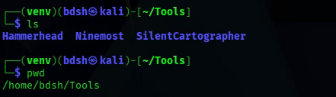

DFIR LLM-Automation Script Manuals
The “SilentCartographerV1” and “Hammerheadv1” scripts use dependencies that must be installed and ran within a python virtual environment (venv). “NinemostV1” does not require a venv because it does not require a file conversion dependency.

Creating a Python Virtual Environment
- Create a virtual environment in the same folder that you want to run your script using the command python -m venv ./venv (1).
- Enter the python venv using the command source ./venv/bin/activate (2).
- Confirm you are in the python virtual environment by inspecting the command line for the “(venv)” prefix (3).
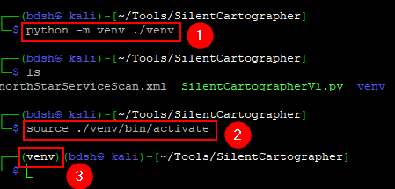
- You can use the same virtual environment to run all 3 tools.

Installing dependencies
For “SilentCartographerV1” and “HammerheadV1” to convert inputs to Token Object Oriented Language (TOON), the dependency “toon-parse” must be installed. For the script to generate pdfs, “pandoc” must also be installed.
- Within the venv (1), use the command pip install toon-parse (2) to install toon-parse.
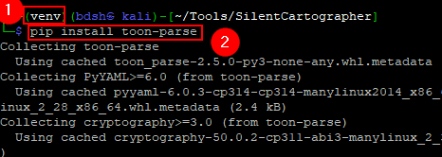

- Within the venv Use the command pip install pandoc (2) to install pandoc.
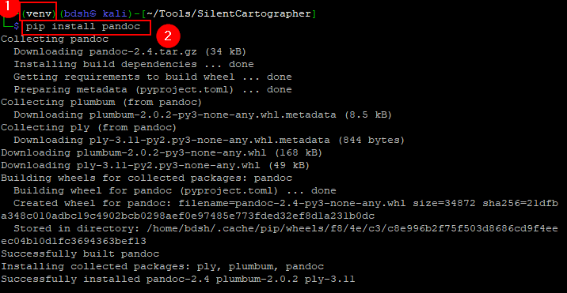

NinemostV1 Manual
(Foremost must be run manually before executing NinemostV1. NinemostV1 scrutinizes contents of the “output” folder generated by Foremost.
- Run Ninemostv1 in the same directory as the “output” folder (1) using the command python NinemostV1.py or ./NinemostV1.py (2)
- Ninemostv1 generates the completed report as a pdf in the same folder it was executed in. (3)
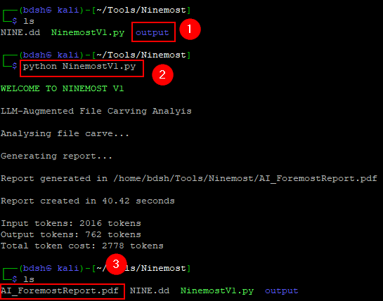

SilentCartographerV1 Manual
- Within the virtual environment, use the command python SilentCartographerV1 or ./SilentCartographerV1 to start the tool (1)
- Type out the Nmap scan you want SilentCartographerV1 to scan (2)
(IT SAYS XML BUT HUMAN READABLE FORMAT WORKS TOO)
- SilentCartographerV1 generates the completed report as a pdf in the same folder it was executed in. (3)
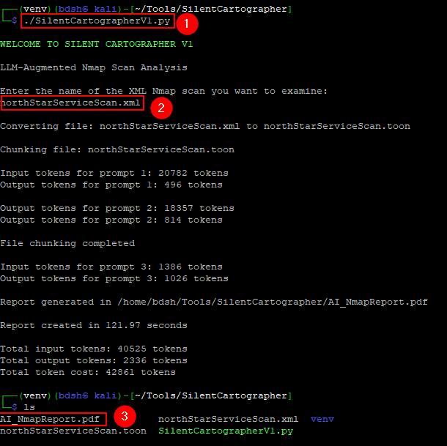

HammerheadV1 Manual
- Within the virtual environment, use the command python HammerheadV1 or ./HammerheadV1 to start the tool (1)
- Type out the name of the pcap you want HammerheadV1 to scan (2)
(IT SAYS XML BUT HUMAN READABLE FORMAT WORKS TOO)
- HammerheadV1 generates the completed report as a pdf in the same folder it was executed in. (3)
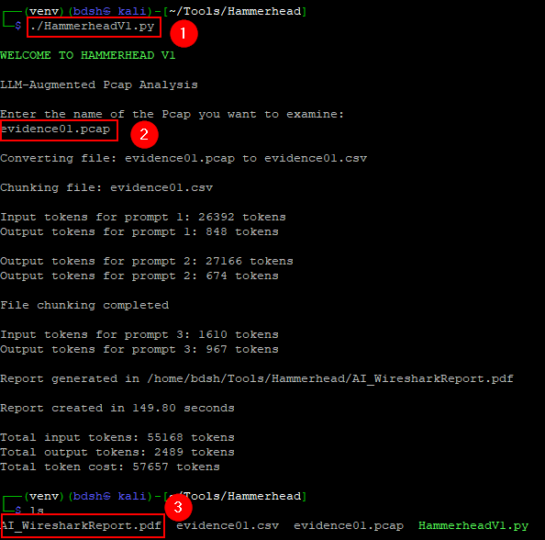

Diagnosis/Testing Support Features
The “cleanup” lines can be commented out, this will keep all residual files, including raw LLM markup output, chunks of data, chunk summaries, and summaries of chunk summaries. This can and has been used to diagnose limitations in the context length of the investigating LLM.
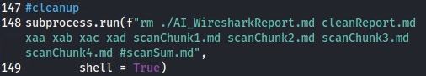
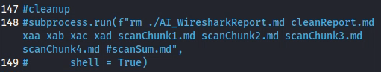
These lines that print “chunkStats” can be uncommented to diagnose and troubleshoot issues with Ollama’s “--verbose” output per prompt, it can also be used to view the full verbose output per prompt with more data fields.
